**PHP/FRAMEWORKS & LIBRARIES GUIDES**

1. Array

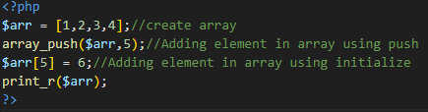

1. Object

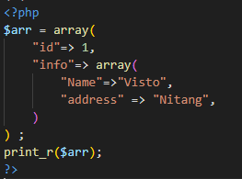

1. Function

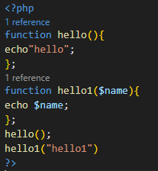

1. Class

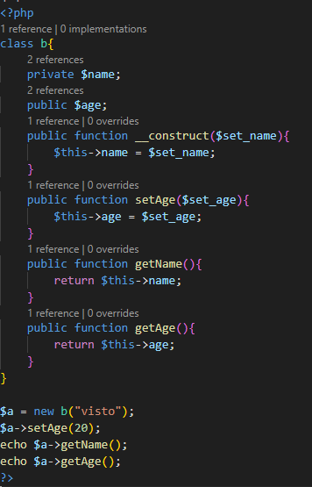

1. Cookie

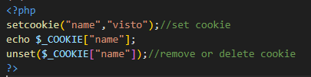

1. Session

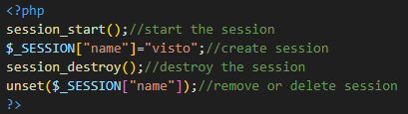

1. Get Header Request

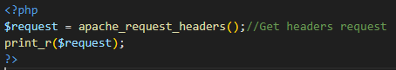

1. Server

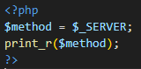

1. Post

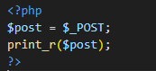

1. Get

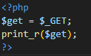

1. Files

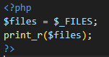

1. JSON

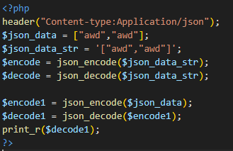

1. Custom Header

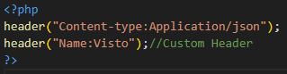

1. File Upload/File Handling